**CampusMart: An E-Commerce Website**

By

**Tanvir Ahammed Bipul**

ID: 221-15-4925

**Md. Jahidul Islam Rakib**

ID: 221-15-4814

**Samsul Arefin**

ID: 221-15-5279

This Report Presented in Partial Fulfillment of the Requirements for the Software Project-I course of B.Sc. in Computer Science and Engineering.

Supervised By

**Sharun Akter Khushbu**

Lecturer (Senior Scale)

Department of CSE

Daffodil International University



**DAFFODIL INTERNATIONAL UNIVERSITY**

**DHAKA, BANGLADESH**

**TABLE OF CONTENTS**

|  |  |
| --- | --- |
|  |  |
| **CHAPTER 1: INTRODUCTION** | **1-2** |
| 1.1 Title | 1 |
| 1.2 Our Unique Idea | 1 |
| 1.3 Merits | 1 |
| 1.4 Demerits | 2 |
| 1.5 Report Layout | 2 |
| **CHAPTER 2: METHODOLOGY** | **3-8** |
| 2.1 User’s Journey | 3 |
| 2.2 Requirement Analysis and Collection | 5 |
| 2.3 Use Case Modeling and Description | 6 |
| 2.4 Prototype | 7 |
| **CHAPTER 3: DESIGN SPECIFICATION** | **9-14** |
| 3.1 Front-end Design | 9 |
| 3.2 Registration Page | 9 |
| 3.3 Log in Page | 10 |
| 3.4 Homepage | 11 |
| 3.5 Products | 12 |
| 3.6 Shopping Cart | 12 |
| 3.7 Profile Page | 13 |
| 3.8 Contacts and Copyright | 14 |
| **CHAPTER 5: CONCLUTION AND FUTURE SCOPE** | **15** |
| 5.1 Discussion and Conclusion | 15 |
| 5.2 Scope for Further Developments | 15 |

**LIST OF FIGURES**

|  |  |
| --- | --- |
| **FIGURES** | **PAGE** |
| Figure 2.1: Use Case | 6 |
| Figure 2.2 Prototype Login | 7 |
| Figure 2.3 Prototype Home | 8 |
| Figure 2.4: Prototype Categories | 8 |
| Figure 3.1: Registration Page | 9 |
| Figure 3.2: Log in Page | 10 |
| Figure 3.3: Homepage | 11 |
| Figure 3.4: Products | 12 |
| Figure 3.5: Shopping Cart | 13 |
| Figure 3.6: Profile page | 13 |
| Figure 3.7: Contacts and Copyright | 14 |

# CHAPTER 1

# INTRODUCTION

## 1.1 Project Name:

“[CampusMart](https://campusmartnew.netlify.app/)”

**1.2 Our Unique Idea:**

We are want to make an e-commerce website for our university campus daily needs basis . in our campus the area is too large so as a result so the distance between hall and restaurant are not near.so we want to delivery food, medicine grocery and e-product by digitally at first we make a website then make an app . [CampusMart](https://campusmartnew.netlify.app/) will be a unique e-commerce platform exclusively designed to serve the needs of our university campus. It will provide a convenient, one-stop solution for students, faculty, and staff to order food, medicine, and grocery items online. This will not only save time but also ensure the availability of essential items for the campus community.

## 1.3 Merits:

* student can order anything very easily and safe time
* specially girls hostel student benifited so much because they can’t go outside after 7pm.
* [CampusMart](https://campusmartnew.netlify.app/)  will offer a seamless and user-friendly interface for ordering food, medicine, and groceries from the comfort of your dorm or office.

Users will have access to a wide range of products and local vendors without leaving the campus.

**1.4** **Demerits:**

* + - Already have competitor like food panda but they are not available this area.
    - Depending on existing local delivery services, [CampusMart](https://campusmartnew.netlify.app/) may face competition and need strong marketing efforts to gain user trust.

**1.5 Report Layout:**

This report is divided into four chapters. The first chapter, "Introduction," covers the key points of the project, Project title, it’s unique idea, merits, demerits and the report layout. The second chapter, "Methodology," describes the practical work that was done. The third chapter, "Design Specification," details the design of the project. The fourth chapter, "Conclusion and Future Scope," discusses the findings of the project and suggests areas for future development.

# CHAPTER 2

# METHODOLOGY

## 2.1 User’s Journey

1. User Registration:

* User visits the website.
* User creates an account by providing personal information (name, email, password etc.).
* User account data is stored in the database.

2. User Login:

* Registered users log in using their email and password.

3. Visiting the site and choosing products:

* Upon login, users can access the site's products information with image , cart and business policy.
* A lot of product’s information is provided from the database and displayed on the website.

4. Selecting a product:

* Users scroll the site, select products and add to their cart.
* After adding to cart , user can choose another one and add to the cart according to their choice.
* Users can order those products instantly or later using the cart.

5. Data Storage:

* User order, cart and delivery address data are stored in the database, helping them with the user’s account

6. Confirmation and Payment:

* Users receive a confirmation for their orders, home delivery.
* Users make payments, if required, securely through the website.

7. Delivery Processing:

* The site only provides the facility of online ordering and home delivery.
* The products will be delivered to the address given by the user.
* If user changes his location he can update the location.

8. Feedback and Support:

* Users can provide feedback, reviews, or contact customer support for assistance.

## 2.2 Requirement Analysis and Collection

**2.2.1 Software Requirements:**

* Visual Studio Code ([VS Code](https://code.visualstudio.com/)): The primary development environment for producing and editing the website's source code was Visual Studio Code, a versatile and capable code editor. It made it easier to code and debug.
* Browser ([Google Chrome](https://www.google.com/chrome/)): For testing and viewing the website, Google Chrome was used as the primary web browser. It enabled the site's front-end components to be inspected and debugged in real time to ensure cross-browser compatibility.
* [Figma](https://www.figma.com/): Figma served as a platform for creating user flow diagrams, which improved the visual aesthetics and usability of the website.

**2.2.2 Language Specification:**

**Frontend**: We will use a modern web development stack with HTML, CSS, and JavaScript for the user interface. Additionally, we will use a frontend JavaScript framework like React for interactive features.

**Backend**: The backend will be built using a scalable language and framework such as Node.js, Python (Django or Flask). This will handle user accounts, order processing, and vendor integrations.

**Database**: We will utilize a robust and scalable database system such as MySQL, PostgreSQL, or MongoDB to store user data, product information, and order history.

**Mobile App**: In addition to the web platform, we will consider developing mobile apps for Android and iOS to provide a more convenient ordering experience.

**2.3 Use Case Modeling and Description:**

Use case modeling helps in understanding the requirements of a system from a user's perspective and ensures that the system is designed and built to meet the needs of its users. It's a valuable tool during the early stages of software development to clarify and define what the software is supposed to do.

In our project use case shows us how it will work. We can easily understand workflow about a project through this use case modeling.

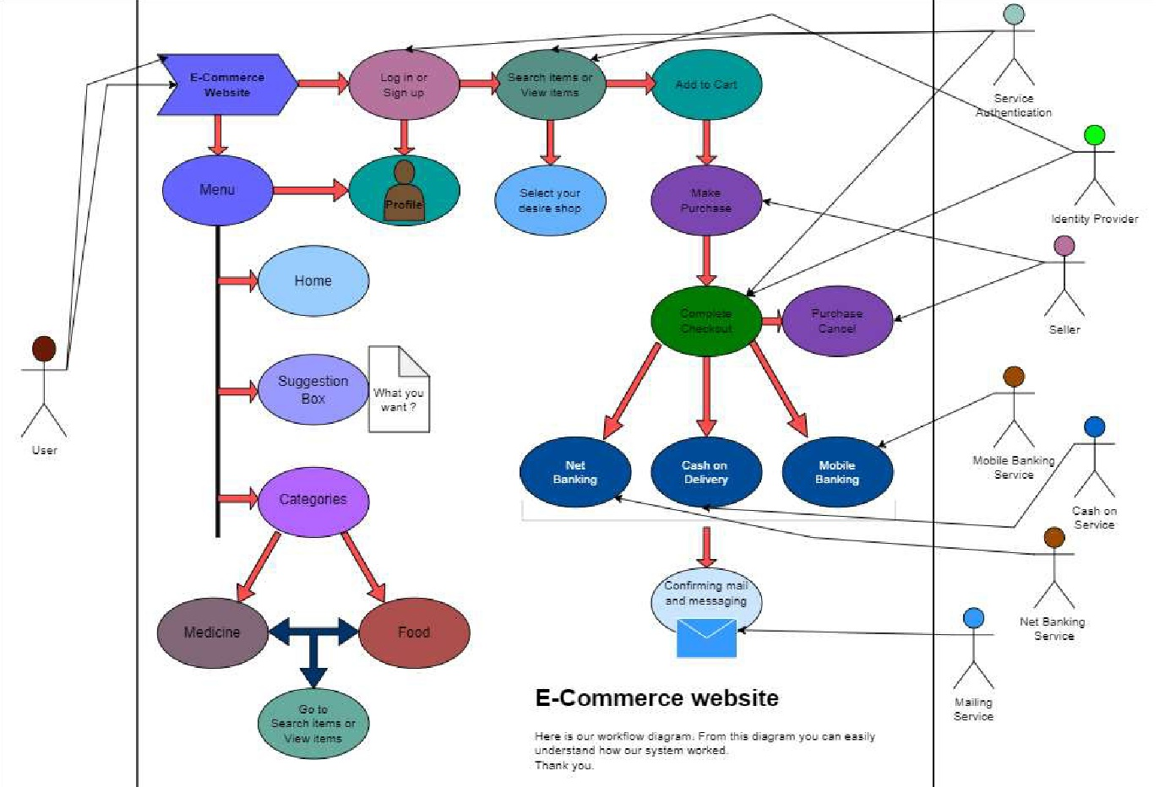

Figure 2.1: Use Case Model

**2.4 Prototype**

**2.4.1 Description:** An app prototype is a crucial early-stage representation of a mobile or web application's user interface and functionality. It serves as a visual and interactive blueprint that allows designers, developers, stakeholders, and potential users to understand and evaluate the app's concept and design before investing significant time and resources into full- scale development. This is our app visualization.

**2.4.2 Prototype Link:**

<https://www.figma.com/file/GuveCl0hmsle4YatO3RMpY/SP_2?type=design&node-id=0%3A1&mode=design&t=5dIj7cCDTACcBbtf-1>

**2.4.3 Prototype pages:**

**Figure 2.2:** This is our Log in page and sign in or sign up**.**

**Figure 2.2:** This is our Log in page and sign in or sign up**.**

**Figure 2.2:** This is our Log in page and sign in or sign up**.**

**CHAPTER 3**

# DESIGN SPECIFICATION

## 3.1 Front-end Design

To attain its wide range of functions, the "CampusMart" website heavily relied on the expert utilization of various programming languages and technologies. The following components were vital in ensuring the project's successful accomplishment:

**HTML (Hypertext Markup Language):** HTML was the foundation for organizing the website's content. It allowed the production of structurally marked-up web pages and ordered the information shown to users.

**CSS (Cascading Style Sheets):** CSS is essential in improving the website's visual aesthetics and user experience. It enabled the application of styles, layout, and design components, resulting in a unified and visually pleasing presentation.

**3.2 Registration Page:**

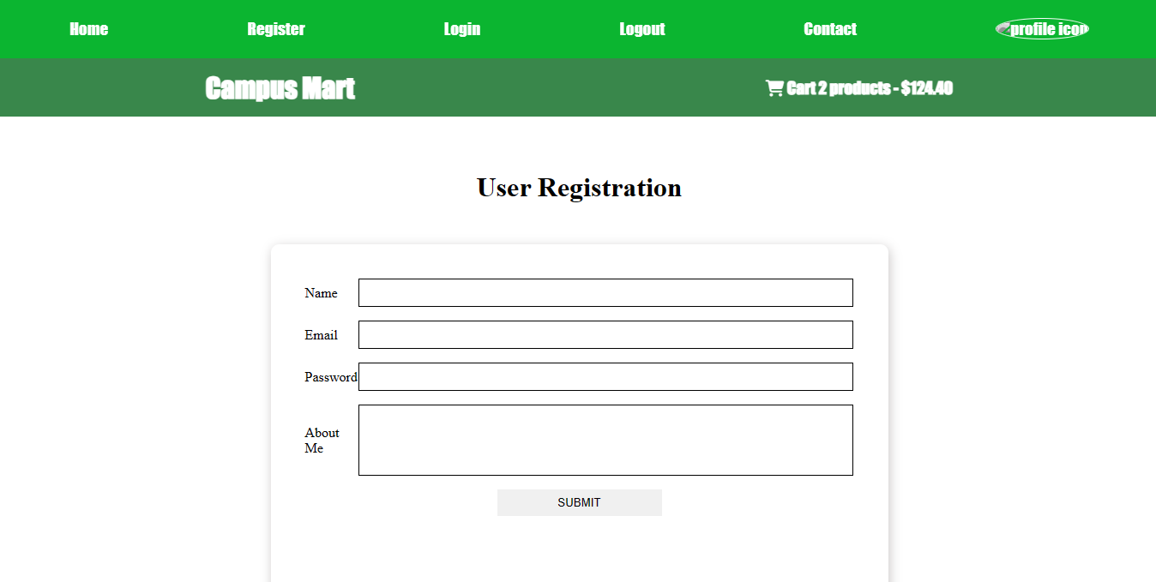

**Figure 3.1: Registration Page**

The sign-up page on the webpage in picture 4.1 is easy to use, allowing visitors to create accounts quickly. The page only asks for essential information, such as name, email address, mobile number, date of birth, and a strong password. This makes the registration process quick and efficient.

## 4.2 Log in Page:

From this page users will start his/her journey to our website. All the section are rooted to this page. So from this page user will get ‘products’, ‘Cart’ and ‘Contact and copyright’ section by scrolling the page down or clicking the buttons on navigation bar.

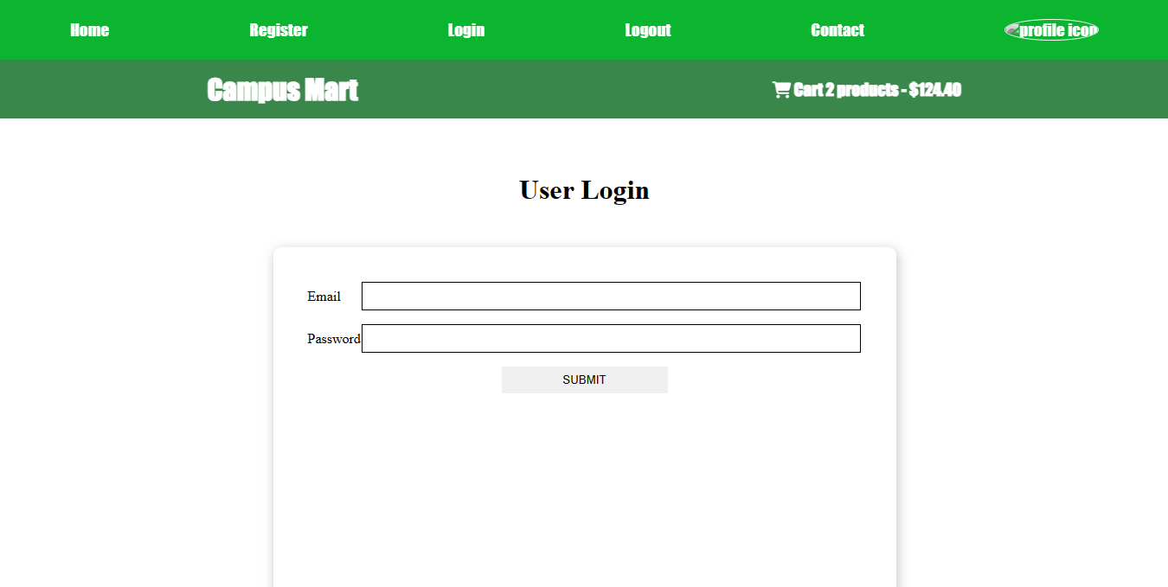

**Figure 3.2: Log In Page**

## 3.4 Home page:

In this section users can discover key information about the website. Users can explore our gallery to know about the products and let grow their interest to buy products. Moreover, they will be able to add in cart, order them instantly by online payment. They can get package delivery at any location. Even they will get the opportunity to change locations and get the package securely.

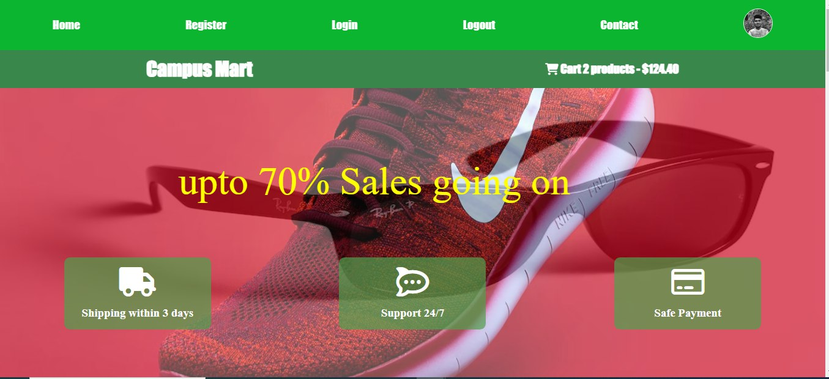

**Figure 3.3: Homepage**

## 3.5 Our Products:

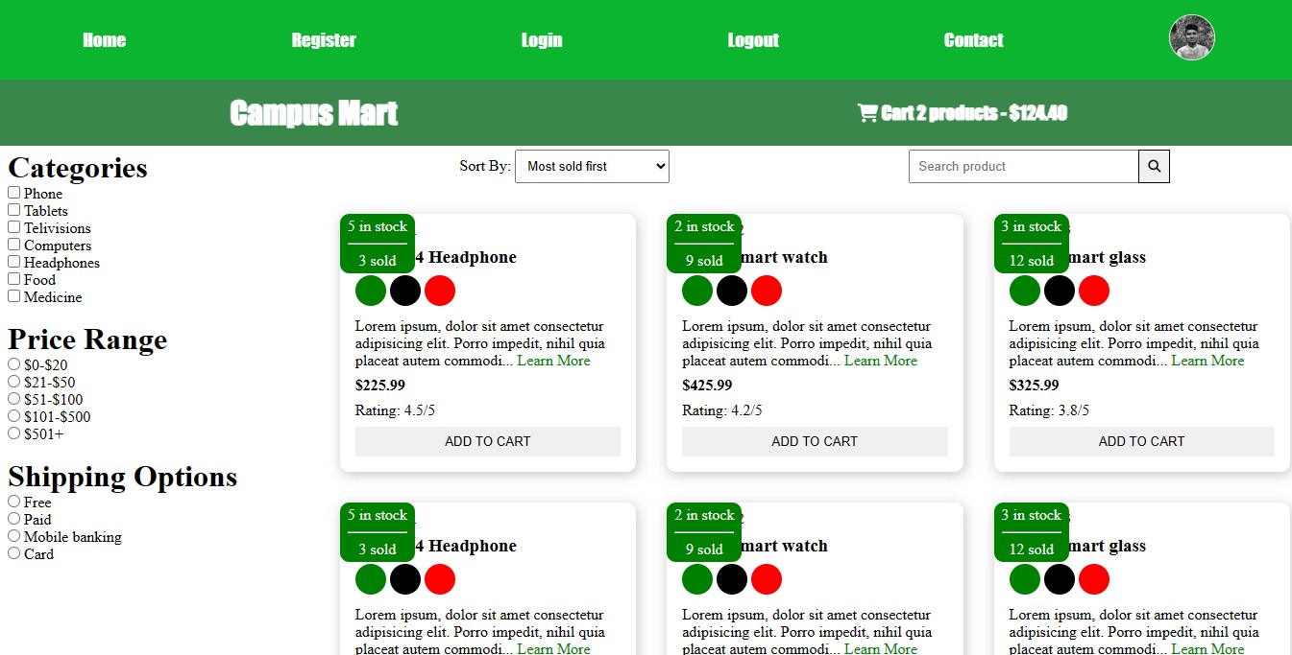

**Figure 3.4: Our Products**

We are proud to offer our customers a wide selection of high-quality products and gadgets at competitive prices. We are also committed to providing our customers with the best possible shopping experience.

## 3.6 Shopping Cart Page:

This section is where user can secure a spot at our restaurant. It's like having a VIP pass to a great dining experience. User can pick the date and time, let us know how many guests are joining and any special requests. We'll make sure a table is ready just for user when he arrives. No waiting around; it's all about enjoying the meal hassle-free.

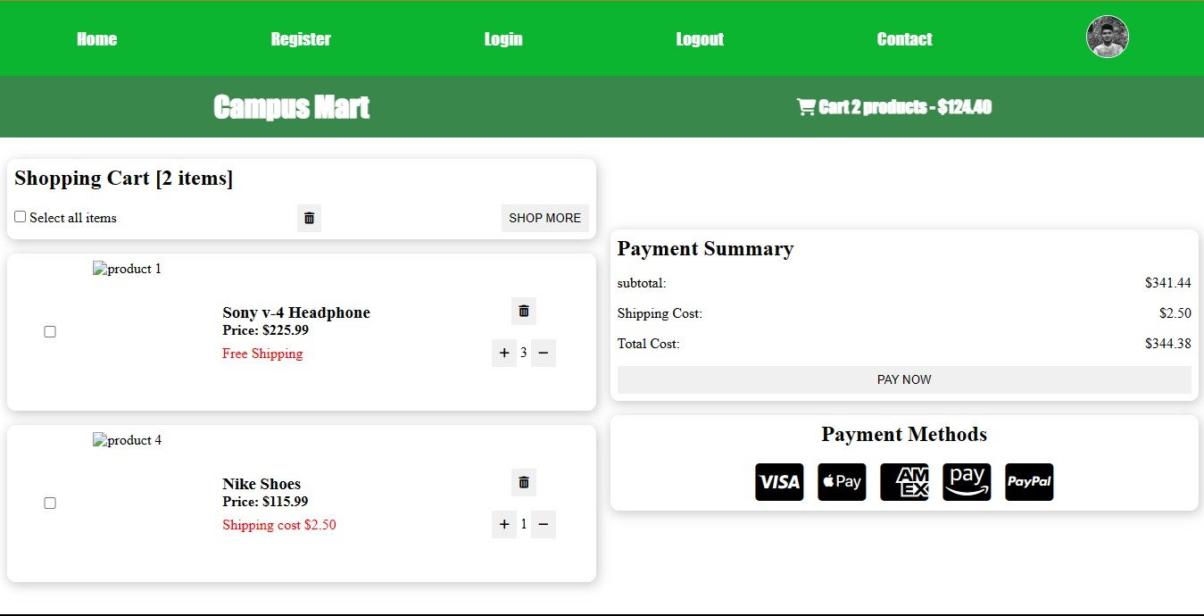

**Figure 3.5: User cart**

## 3.7 Profile page:

In this page user will be able to check their profile information. They will be able to edit or update their profile at any time including profile pictures.

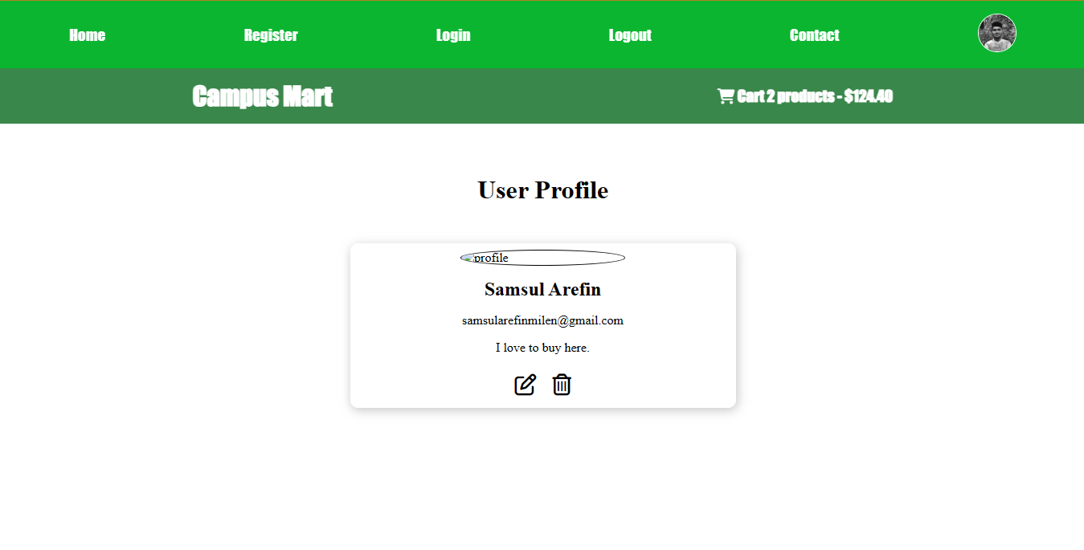

**Figure 3.6: Profile Page**

## 3.8 Contact and Copyright:

In this section clients will be given the option to be connected with the authority. They will be able to complain about their problem. Besides, we will let the user to chat directly with a representative.

Here will also be some information and notice about the safety and copyrights.

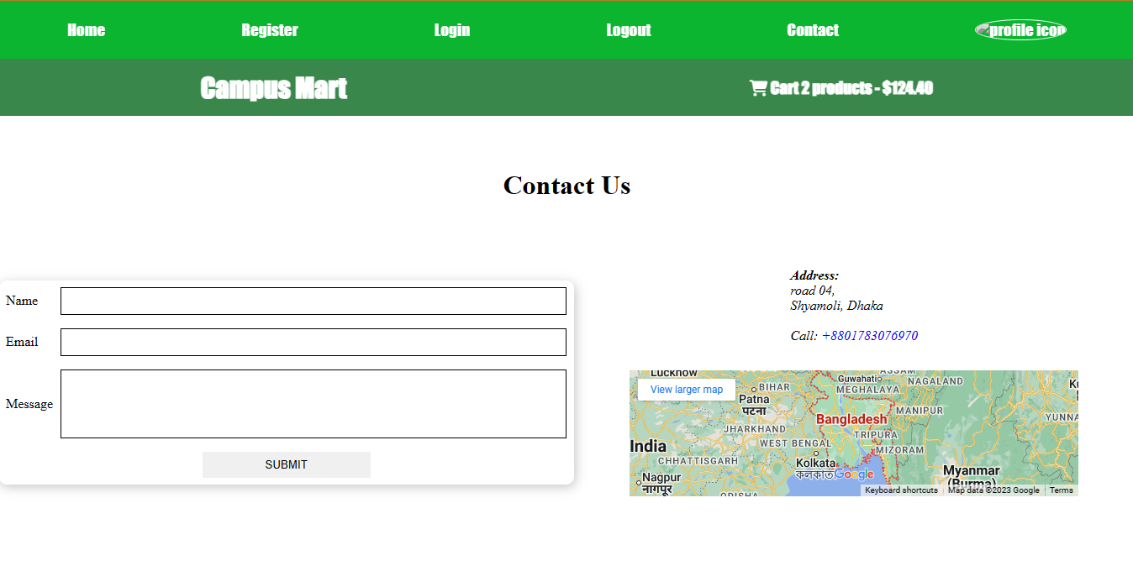

**Figure 3.7: Contact and Copyright**

**CHAPTER 4**

# CONCLUSION AND FUTURE SCOPE

**4.1 Discussion and Conclusion**

The [CampusMart](https://campusmartnew.netlify.app/) e-commerce website was created using the latest web development technologies to provide a sleek, user-friendly, and interactive shopping experience. It features a variety of innovative features, such as personalized shopping, comprehensive product search, and a robust customer support system. We are proud of the [CampusMart](https://campusmartnew.netlify.app/) website and the value it offers to our customers. And finally, we are also proud to create such a website for students and teachers.

**4.2 Scope for Further Developments**

Our team endured many challenges while working on this project, including content management, cross-device testing, CSS and stylistic complexities, and ensuring data correctness. These challenges were difficult, but they helped us learn and grow. We plan to add more features to our website in the future, and we are committed to making it more user-friendly and faster by listening to feedback from our customers.